Registering for Aftercare and Compass Day

From the King Murphy Mountain School Web site, https://www.king-murphy.ccsdre1.org/
Select Compass Day under Extracurriculars
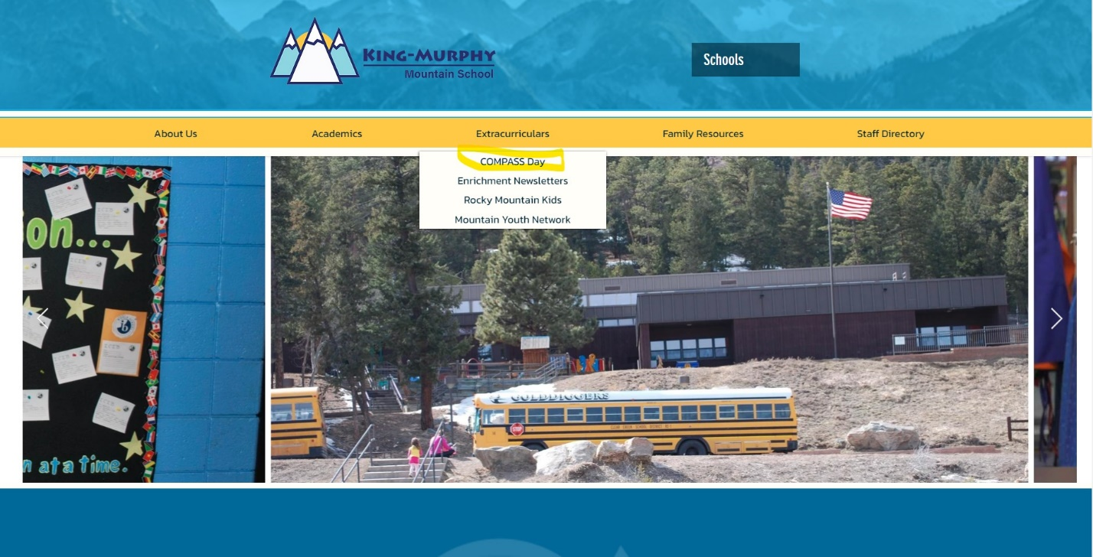

Once on that page (currently outdated info on this page but all the links are still correct), this is what you see – click on COMPASS Day Calendar button.

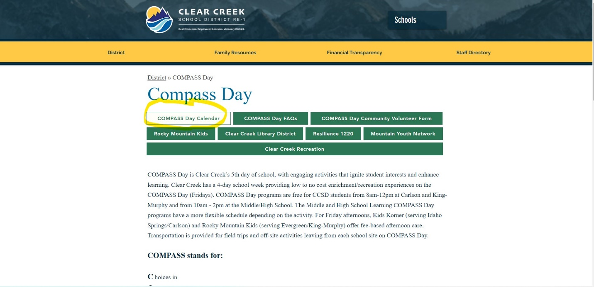

When you click on that it takes you to this calendar page in the Sawyer system. Click the Log In link (upper right).
Here is a direct link to the compass day registration page https://www.hisawyer.com/clear-creek-school-district-re1/schedules/widget_calendar?slug=clear-creek-school-district-re1&year=2023&month=5

You will land on this page – log in or create an account.
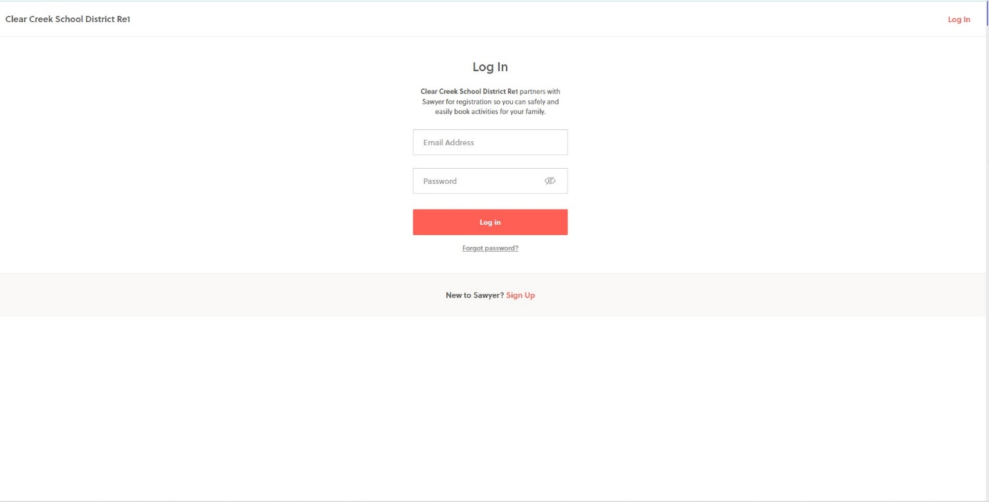

Once logged in (and if you remain logged in), the calendar page now looks like this (it will always open to May):

Scroll to the month you are looking for and you will see items on the calendar available to register for – Eagles Enrichment.
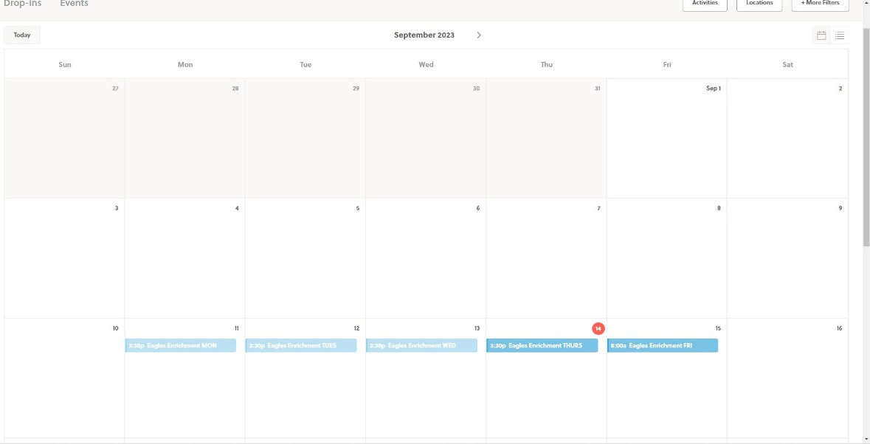
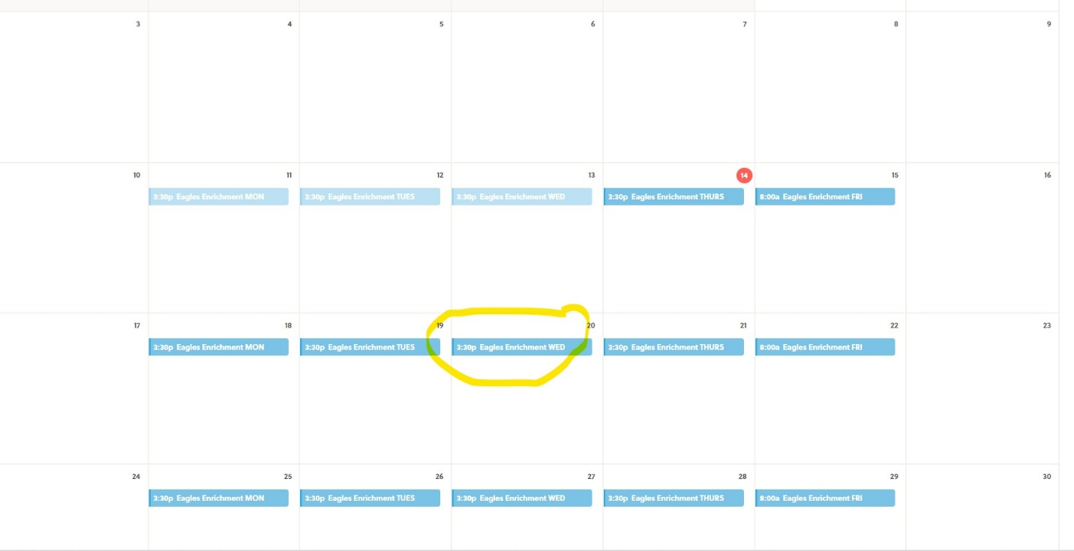
Click on the blue line on the day you want to register for and this comes up, click more info:
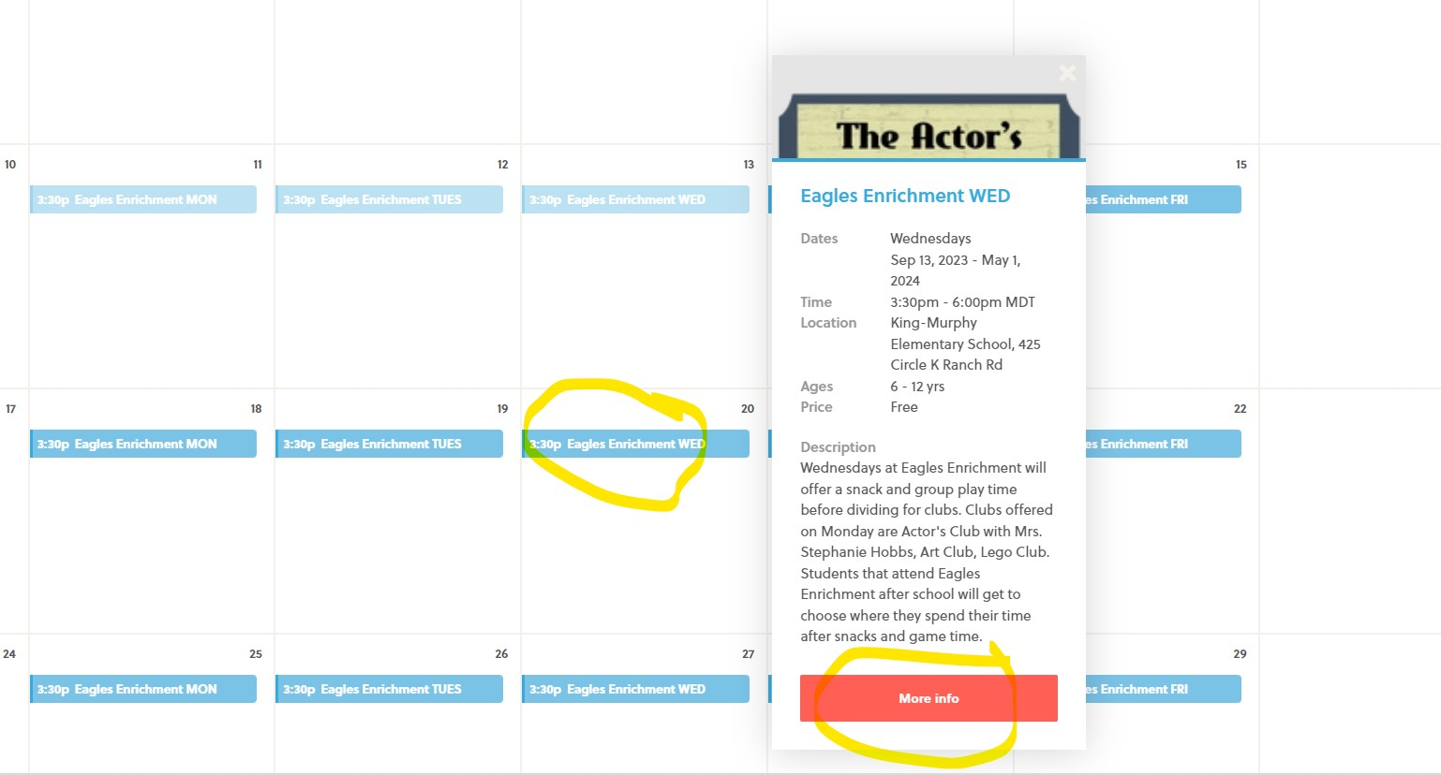

That lands you here – click register:
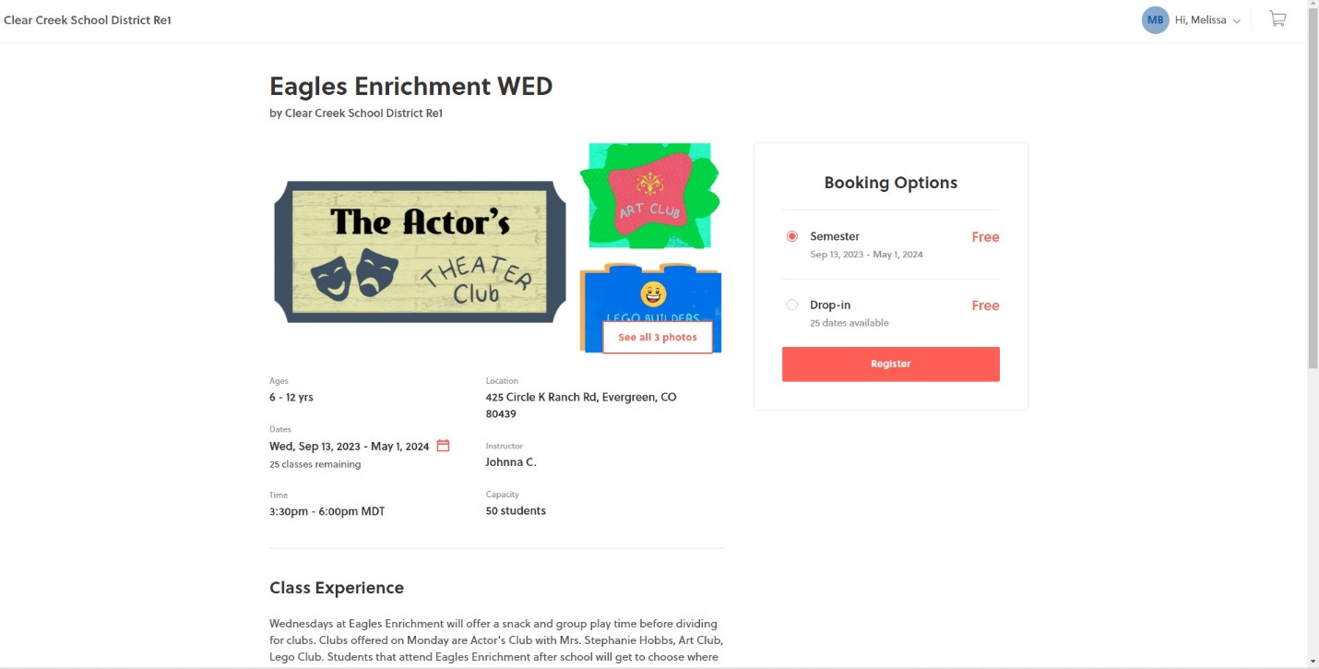

You can register for single days or the full semester. If you pick drop in you can select multiple days. Make your pick and register, continuing through the screens to add to cart. And then continue to payment. THERE IS NO CHARGE – this is just the procedural process for registration as this is an activity registration system.
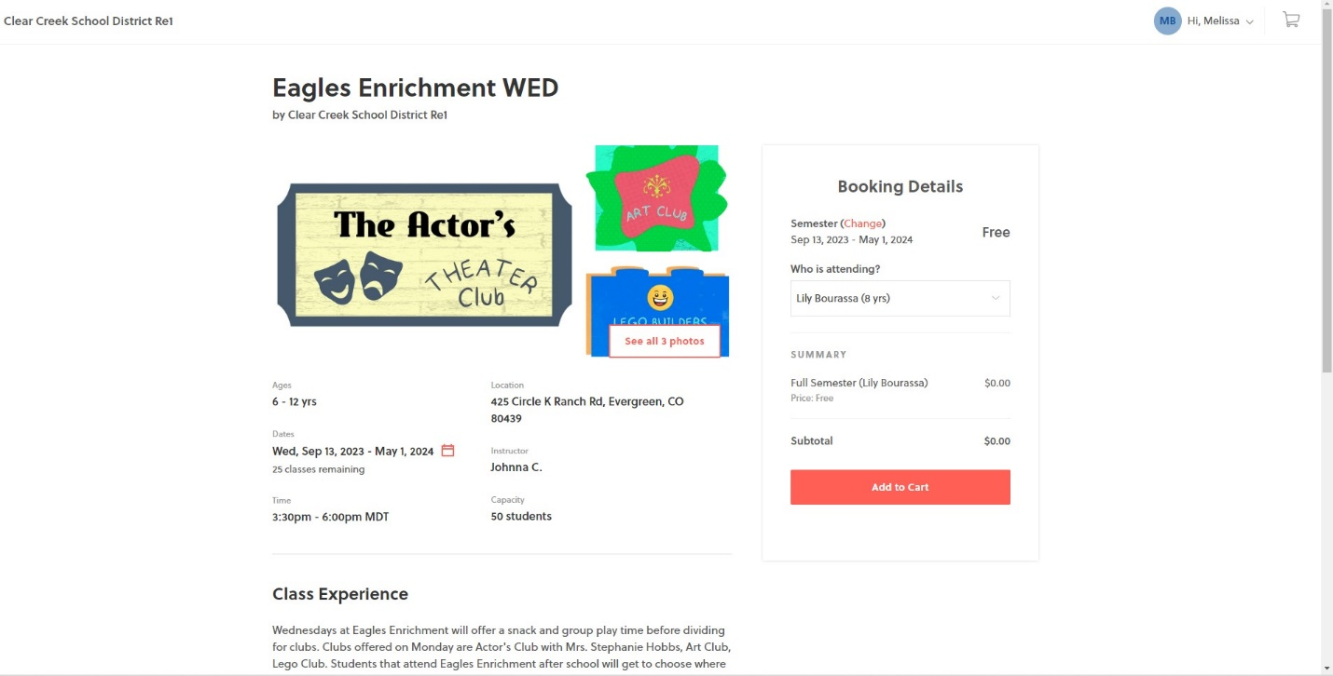
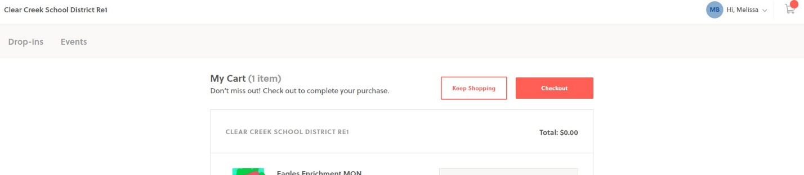

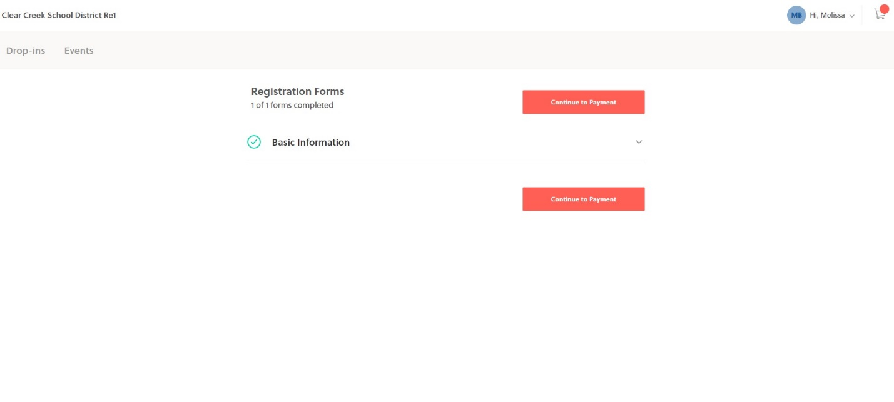

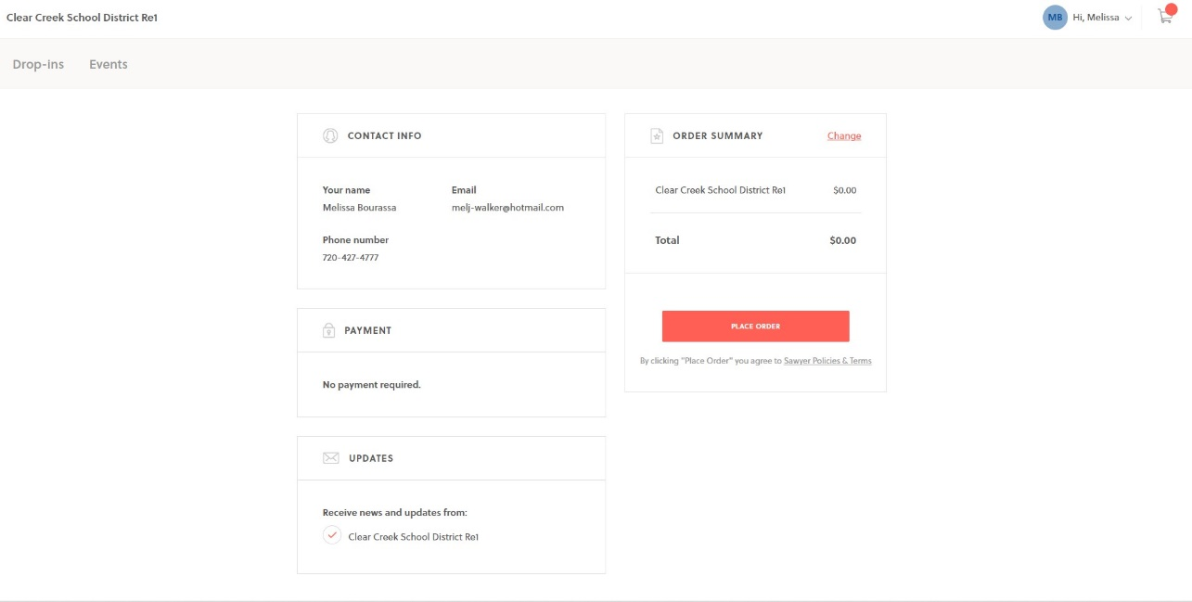
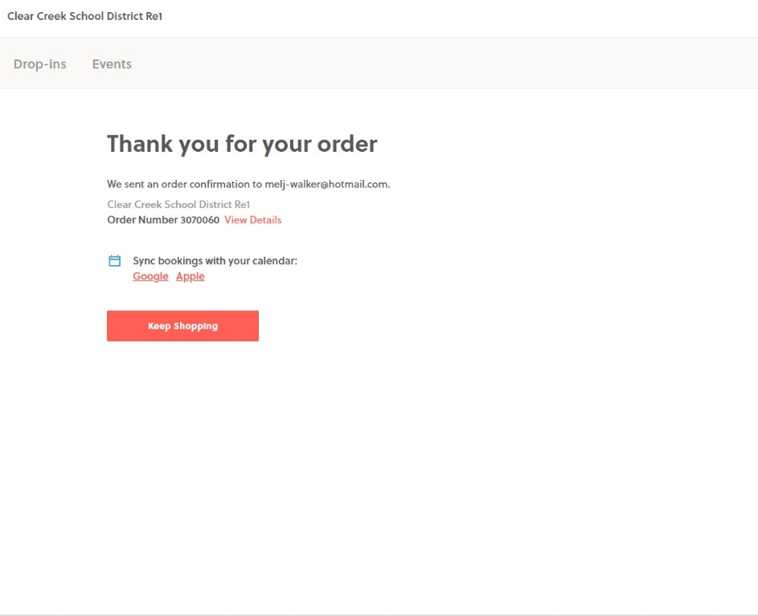

You should get a confirmation email:
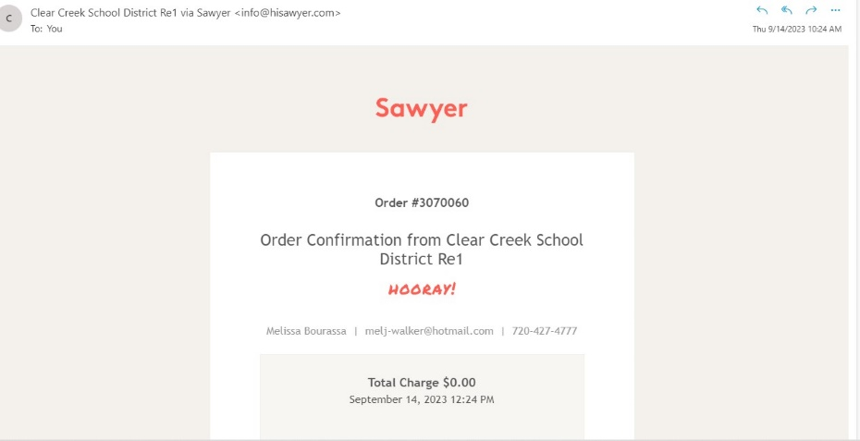

Hooray!!

